FOR IMMEDIATE RELEASE
MNS Attorneys Celebrates 23 Years of Black Excellence and Empowerment
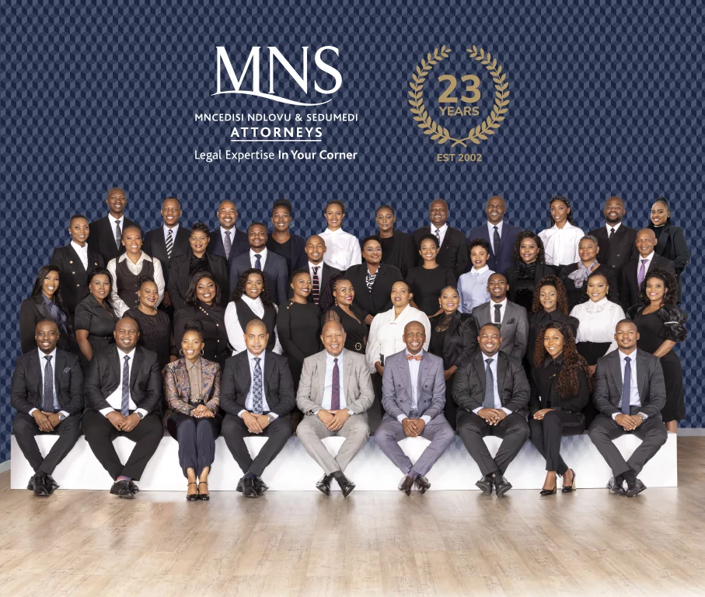
Johannesburg, South Africa – May 2025 – MNS Attorneys, a premier black-owned South African law firm, is proud to mark its 23rd anniversary—celebrating more than two decades of unwavering commitment to justice, transformation, and black excellence in the legal profession.
Founded in 2002 by Mr. Mncedisi Ndlovu and Tshiamo Sedumedi, MNS Attorneys emerged during a critical period in South Africa’s democratic journey. At a time when black representation in the legal and corporate governance space remained limited, the founders of MNS set out with a bold mission: to establish a world-class law firm that reflected the values of equity, transformation, and professional excellence.
Today, MNS Attorneys is a fully-fledged commercial law firm with a national footprint and a formidable reputation in sectors such as corporate and commercial law, public law, infrastructure development, regulatory advisory, and dispute resolution. The firm has been a trusted advisor to major public and private institutions, consistently delivering innovative legal solutions with integrity and precision. Notable clients include the City of Johannesburg and the Passenger Rail Agency of South Africa (PRASA), where MNS has played a key role in navigating complex legal and governance issues.
From its inception, black excellence has been a cornerstone of the MNS identity. The firm has played a leading role in nurturing a new generation of black legal talent, with a strong emphasis on mentorship, leadership development, and community engagement. This legacy of empowerment has not only transformed the lives of its practitioners but has also contributed meaningfully to the broader transformation of South Africa’s legal landscape.
MNS Attorneys believes in inspiring and grooming the next generation of quality black attorneys who can confidently hold their own within the legal fraternity. In the past year alone, the firm welcomed five new candidate attorneys into the fold—continuing its tradition of investing in young legal minds. Over the past five years, many of these candidate attorneys have progressed through the ranks, taking on roles as Associates and Senior Associates. Their growth is a testament to MNS's deep commitment to long-term career development and transformation within the profession.
Reflecting on the journey, Mncedisi Ndlovu, Chairman of the Board and one of the founding members of MNS Attorneys, said:
“When we started MNS, we dreamed of creating more than just a law firm—we envisioned a platform for empowerment, transformation, and black excellence. Over 23 years, we’ve remained true to that vision. Our firm is not only defined by the quality of the legal work we do, but also by the values we uphold and the opportunities we create. I am immensely proud of our team and grateful for the trust our clients have placed in us. The journey continues—and the future is bright.”
The firm’s excellence was recognised in 2024 at the prestigious Best Lawyers Awards, where several MNS professionals were honoured for their outstanding work:
Mr. Mncedisi Ndlovu – Corporate Law
Mr. Tshiamo Sedumedi – Labour and Employment Law
Mr. Mandla Mnisi – Corporate Law
Mr. Thobani Mnyandu – Construction Law
As MNS Attorneys celebrates this significant milestone, the firm remains resolute in its commitment to ethical leadership, legal innovation, and socio-economic transformation. With its eyes set firmly on the future, MNS will continue to break new ground, empower the next generation of legal minds, and stand as a beacon of excellence and equity in the legal profession.

